Payroll Management System for Information Technology Company

Version 1.0

Revision History

|  |  |  |  |
| --- | --- | --- | --- |
| **Date** | **Version** | **Description** | **Author** |
| 18/12/2019 | 1.0 | Final | Bui Tuan Anh |
|  |  |  |  |
|  |  |  |  |
|  |  |  |  |

Table of Contents

1. Introduction 4

1.1 Purpose 4

1.2 Scope 4

1.3 Definitions, Acronyms, and Abbreviations 4

1.4 References 4

1.5 Overview 4

2. Flow of Events—Design 4

2.1 Class Diagrams 4

2.1.1 Top-level class diagram 4

2.1.2 Detail class diagram 5

2.1.3 Model class diagram 6

2.2 Sequence Diagram 7

3. Derived Requirements 7

# Introduction

## Purpose

This document describes how the Add Departments Use-Case is realized within the design model, in terms of collaborating objects

## Scope

This document applies solely to the use case: Add Departments which will be developed by JavaTech Group.

## Definitions, Acronyms, and Abbreviations

* MVC: Model – View – Controller.

## References

[1] ***Use-Case Specification: Add Departments***, Bui Tuan Anh, JavaTech.

## Overview

In the following section, Use-Case Realization Specification of the Add Departments Use-Case of the Payroll Management System is provided in detail. This document described by class diagram and sequence diagram that demonstrate the flows realization in further detail. In the last section, the requirements have not been provided in the design model.

# Flow of Events—Design

## Class Diagrams

### Top-level class diagram

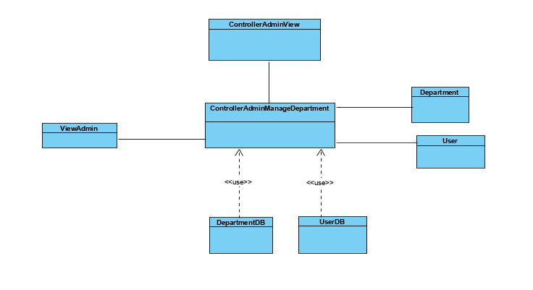

### Detail class diagram

#### Controller class diagram

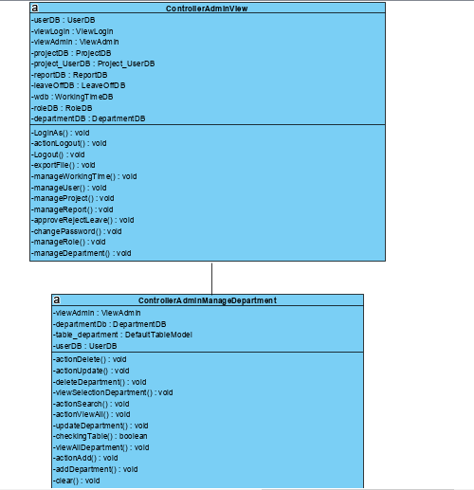

### Model class diagram

* Data Access Class

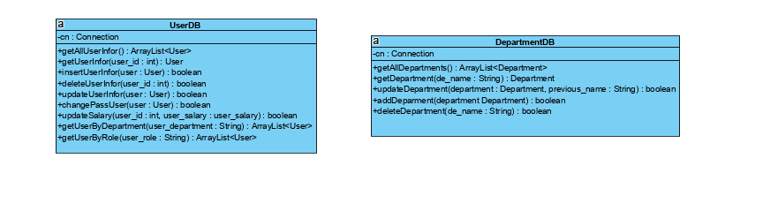

* Entity Class

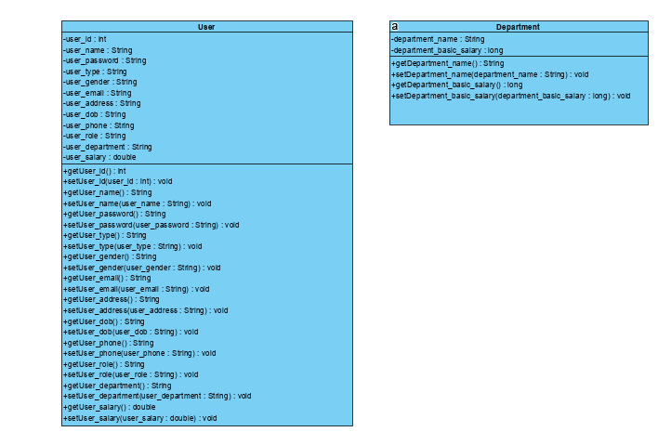

## Sequence Diagram

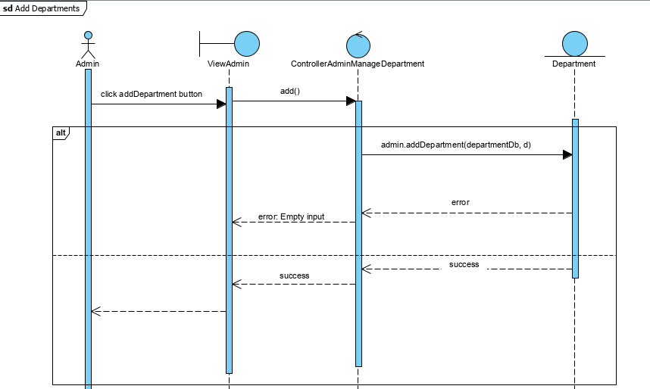

# Derived Requirements

No derived requirements.